A Review of Existing Information Relevant to the Process of Purifying Molten Fluoride Salts

Kyle Williams
9/1/2022

Table of Contents
1. History of Molten Fluoride Salt Purification 4
2. Types of Molten Salt and their Properties 6
3. Effects of Contaminants on Molten Salt Performance 7
3.1 Oxygen 7
3.2 Sulfur 7
3.3 Structural Metals 7
4. Purification Methods 9
4.1 HF-H₂ Sparging 9
4.2 NF₃-H₂ Sparging/NF₃ Baking 13
4.3 NH₄HF₂ Baking 18
4.4 Electrolytic Purification 19
5. Additional Steps 22
5.1 Continued H Additions 22
5.2 Reducing Metal Additions 22
5.3 Filtration 22
6. Corrosion in Structural Materials 23
6.1 Corrosion Due to Hydrofluorinating Reagents 23
6.2 Embrittlement Due to Hydrogen 24
6.3 Corrosion Due to Molten Salt 24
6.4 Corrosion Due to Added Fuel 27
7. Compatibility of Candidate Structural Materials 28
7.1 Ni Alloys 28
7.2 Steels 28
7.3 Copper 29
7.4 Carbon 29
8. References 30

1. History of Molten Fluoride Salt Purification
The concept of using molten fluoride salt loops has existed since at least the late 1940s, and the first experiments conducted toward building one were performed as part of the Aircraft Reactor Experiment (ARE) at Oak Ridge National Lab starting in 1949, practically ending in 1957, and officially concluding in 1961.
In 1952, ARE workers decided that the fluoride compounds purchased to create experimental molten fluoride salt eutectics were of an unacceptable level of purity, as oxide impurities in the salt were causing a sludge to form as experiments proceeded which clogged pipes [1]. An initial proposed purification process consisted of heating the salt mix to 600°C under vacuum to remove any water from the system, followed by a hydrogen gas (H₂) sparge at temperature to remove excess fluorine from the system [1]. Later that same year, they discovered that a lab scale process of treating the salt with an HF-H₂ atmosphere could be scaled up and applied to reduce the level of sulfur contaminants in the salt to acceptable [2]. This process would later be refined extended to also remove most oxide contaminants present in the salt, creating the method of purification through hydrofluorination that will be described in more detail in Section 4.1. Later that same year, it was discovered that adding reducing agents to the molten salt, long thought to only have deleterious effects, could actually help prevent corrosion, so long as an excessive amount was not added [3]. It was also discovered that a longer purification process and an additional step involving sparging with pure hydrogen gas could be used to further reduce corrosion [3]. In 1953 it was found that the hydrogen sparge was reducing corrosion by reducing metals dissolved in the mix during fluorination to their metallic state and removing excess fluorine from the system [4]. In 1954 it was found that of these metals, nickel would reduce out quickly by hydrogen sparging while iron and chromium would be rate limiting and that the presence of these metals in in a molten salt solution could cause UF₄ from fuel to be reduced to UF₃ [5]. This is also around the time they started experimenting with electrolytic means of purifying the salt [5]. In 1955 it was discovered that hydrogen sparging alone would not reduce out appreciable concentrations of chromium at a practical rate and that reducing agents would need to be added [6]. A new type of reaction vessel utilizing copper lined stainless steel in place of nickel was also put into use in order to scale up salt production [6].
The lessons learned from the initial years of the ARE were then taken into a new project known as the Molten Salt Reactor Experiment (MSRE) with a focus shifted towards conducting experiments directed at making a reactor for producing commercial power. This project, beginning in from 1957, starting operation fueled in 1965, concluding fueled operation in 1969, and continuing experiments until 1975, provided the largest single source of data for the performance, requirements, and behaviors of a commercial power plant scale molten salt loop.
Beginning in 1957, it was noticed that the new salt chosen (Li₂BeF₄) was substantially more difficult to purify than the old salt (NaZrF₅), requiring longer sparge times [7], [8]. In 1959, tests using molten ammonium bifluoride (NH₄HF₂) showed that it performs an adequate job of converting metal oxides into fluorides, making it a viable purification method [9]. In 1963 a standard fuel, flush, and cooling salt purification operation procedure had been established, once again using the proven method of hydrofluorination in nickel lined vessels and averaged a processing time of 164 hours per batch [10]. This operation remained essentially unchanged throughout the period of fueled operation [10], [11].
During and after the conclusion of fueled operation experiments into purifying salt eutectics shifted from removing impurities to removing fission products produced during operation. Removal of fission products was largely accomplished through fluorination. In 1972, experiments were underway to test the viability of a “frozen-wall fluorinator” [12], [13]. Studies into the viability of this design had been underway throughout the operating and post operating period [12], [14]. The purpose of this is rather self-explanatory in that a thin layer of fluoride salt would cover walls of the fluorination vessel and kept below its melting point to remain solid, thus creating a protective salt layer and allowing for more aggressive fluorination agents (notably fluorine gas or F₂) to be used with minimal attack on structural metals [12], [13]. The complication of this design is that it requires internal heating, for which autoresistance heating was tested, but radiofrequency induction heating was also considered [12], [13], [15]. Although designed for the aggressive removal of fission products from used salt, this design, if proven viable, could be usable in purifying unused salt as well. Also tested was the distillation of used salt to remove fission products; however, this proved inefficient [11]. After this report little innovation into the salt purification process was found. This is likely due to the project being essentially dead by this point, so funding and manpower were minimal until all work on the project ceased in 1975.

2. Types of Molten Salt and their Properties
Focus is directed on two types of fluoride salts: Li₂BeF₄ (FLiBe) and LiNaKF₃ (FLiNaK). Any mention of other salts is done so for the sake of approximating behaviors to these two types.
FLiBe is a 0.66:0.34 molar mixture of LiF and BeF2 respectively. It has a melting point of 459°C [16], [17]. It melts into a clear, neutral solution making noticing contaminants rather easy. It is typically favored as a fuel salt due to its more favorable nuclear cross section neutral Lewis acid-base chemistry [18]. A FLiBe based mixture was used for the fuel loop of the MSRE project[19]–[22]. Its density (ρ), dynamic viscosity (η), thermal conductivity (λ), and heat capacity (Cp) are shown in equations 1-4 [17].
$$ρ \left(\frac{kg}{m^{3}}\right)=2413.03-0.4884*T\left(K\right), T∈[788-1094] (1)$$
$$η \left(Pa* s\right)= 0.000116·exp\left( 3755 T\left(K\right)\right), T∈\left[800-1050\right] (2)$$
$$λ\left(\frac{W}{m*K}\right)=1.10 (3)$$
$$Cp\left(\frac{J}{kg*K}\right)=2385 (4)$$
FLiNaK is a 0.465:0.115:0.42 molar mixture of LiF, NaF, and KF respectively. It has a melting point of 454°C [17]. It melts into a clear, chemically basic solution [18]. FLiNaK is often used in place of FLiBe in molten salt research not involving fuel, despite its lower heat capacity, due to its lack of any highly toxic beryllium, however it is more corrosive than FLiBe due to the presence of free fluoride ions in its molten state [18]. Its density, dynamic viscosity, thermal conductivity, and heat capacity are shown in equations 5-8 [17].
$$ρ \left(\frac{kg}{m^{3}}\right)=2579.3-0.6237*T\left(K\right), T∈[933-1170] (5)$$
$$η \left(Pa* s\right)=0.0000249*{10}^{\frac{944}{T(K)}} , T∈\left[773-1163\right] (6)$$
$$λ\left(\frac{W}{m*K}\right)=0.85 (7)$$
$$Cp\left(\frac{J}{kg*K}\right)=1880 (8)$$

3. Effects of Contaminants on Molten Salt Performance
The presence of contaminants in a molten salt mix causes a series of undesirable reactions to occur, overall decreasing the performance of the salt. Among these reactions, one of note is the acceleration of corrosion of structural metals in direct contact with the salt. Although the effects of contaminants on salt are not sustained, they can have immediate pronounced effects on corrosivity [23].

3.1 Oxygen
Due to their relatively high concentrations and their increased time to remove, the most concerning contaminants of note are oxides and hydroxide compounds [18]. Since every constituent fluoride salt used in both FLiBe and FLiNaK is hydroscopic, water from the air will be absorbed into the salt. Water reacts with the fluorine ion in fluoride salts to form HF, metal hydroxides, and metal oxides. In salts containing UF₄, a high enough oxide concentration was found to cause UO₂ to fall out of solution and collect in lines, creating hot spots [10], [21]. This issue was minimized by MSRE scientists through the addition of up to 5% ZrF₄ to the salt mixture to act as a thermodynamically favored oxide buffer [21]. The HF formed from the reaction between water and salt can corrode structural materials such as Cr and Fe through fluorination. Despite this, Aia et all, found that high enough concentrations of oxides in molten FLiNaK, in excess of 1000 ppm, can actually retard the corrosion of 316SS [24]. A high oxide concentration was found to change the corrosion products from Fe₃O₄ and Cr₂O₃ to CrLiO₂, which formed a more stable passivation layer between the salt and metal [24].
Originally, oxygen concentration was measured by reacting salts with an aggressive fluorinating agent, and measuring the amount of oxygen released [25]. While attempts using KBrF₄ were successful at measuring up to 98% of the oxygen content, aggressive fluorinating agents present multiple safety issues, as will be discussed in Section 4 [25], [26]. Cyclic voltammetry can be used to measure a change in the amount of oxygen ions [27]; however, since the exact forms of oxides in the salt are unknown, it is unknown if this method is sufficient to accurate. Recently, combustion analysis became the standard for determining oxygen concentration. Combustion analysis works by melting the salt in a graphite crucible at a high enough temperature such that the oxygen in the salt will react with the crucible to form CO, which can then be converted to CO₂ and measured via thermal conductivity detectors [26].

3.2 Sulfur
Sulfide and sulfate contaminants encourage increased corrosion by altering redox potential. Sulfur compounds can attack noble metals like nickel and form NiS, which can then be attacked by fluoride ions to form NiF, which will dissolve into the salt solution, corroding loop structures [10], [21]. Although less abundant in constituent salts used today, sulfur was a major contaminant of consideration for MSRE operations, due to large amounts of it being present in their LiF supply [10], [28]. Sulfates and sulfites also decompose at high temperatures (600-1000°C), releasing more oxygen into the salt [29]. Sulfur contaminants tend to be removed faster and more completely than oxygen contaminants [30].
A standard method of measuring sulfur content was not found. This is likely due to the lack of a need for one. Sulfur is completely removed from the system long before oxygen for all of the purification methods discussed [27], [30]–[32].

3.3 Structural Metals
Structural metal contaminants, such as fluorinated Cr, Fe, and Ni, affect the nuclear cross section of the salt, and can contribute to loop clogging by deposition to pure metals, and can increase corrosion rates [10], [29]. Molten fluorides prefer to attack Cr over Ni or Fe [23], [33]–[37]. Because Cr is the preferred metal to attack, any Ni or Fe in the salt as fluorides will shift the redox potential and cause Cr to be further attacked through substitutive fluorination [29]. An excess of Cr in the salt can cause it to plate out of solution onto other metal surfaces, diffusing into those surfaces and weaking the metals resistance to future corrosion when the redox potential of the salt changes again [29]. Outside of salt corrosion, metal fluorides are often introduced by the oxidation of structural alloy constituents by contact with strong fluorinating agents [21], [29], [38]. These metal fluoride contaminants then dissolve into the molten salt mix to disrupt its chemical equilibrium.
The concentration of metal impurities can be easily measured through inductively coupled plasma (ICP) spectroscopy [26]. Just like with oxygen, cyclic voltammetry can also be used to determine the metal concentration relative to a standard but lacks the ability to give precise values [27], [39].

4. Purification Methods
For the purposes removing the above-mentioned contaminants, hydrofluorination has proven to be the most effective method of purifying molten fluoride salts by ARE and MSRE scientists [3], [21]. Hydrofluorination, in these cases, is used as a blanket term to describe any process where a substance is oxidized by a fluorinating agent then reduced by a hydrogenating agent, producing HF gas in the process. This method can be largely varied using different fluorinating agents. Conceptually, if the redox potential is the only property observed, pure fluorine gas would be the best for this purpose. F₂ was the first fluorinating agent used by the MSRE project for their molten salt purification needs; however, pure fluorine gas proved to be too corrosive to reactor vessels and was replaced [21]. Varying the hydrogenation agent is less flexible, as H₂ gas has been used exclusively due to its ease of access, lack of corrosive properties, and lack of toxicity.

4.1 HF-H2 Sparging
HF-H₂ sparging is by far the most accepted and well documented form of purifying molten fluoride salt mixtures. This method consists of bubbling a mixture of anhydrous HF gas and H₂ gas through the molten salt in a sparge-tank-like reaction vessel.

4.1.1 Chemistry
HF-H₂ sparging removes oxygen and sulfur by the through the reaction mechanisms shown in equations 9-13 [30].
$$O^{2-} + 2HF⇆ H_{2}O+{2F}^{-} (9)$$
$${OH}^{-} + HF⇆ H_{2}O+F^{-} (10)$$
$${{SO}_{4}}^{2-} + 4H_{2}⇆ S^{2-}+ 4H_{2}O \left(11\right)$$
$${{SO}_{3}}^{2-} + 3H_{2}⇆ S^{2-}+ 3H_{2}O (12)$$
$$S^{2-} + 2HF⇆ H_{2}S+{2F}^{-} (13)$$
HF, like all fluorinating agents, is corrosive to structural metals (Me) through the reaction mechanism shown in equation 14 [30].
$$xMe + yHF⇆ {Me}_{x}F_{y}+0.5yH_{2} (14)$$
The corrosion of structural metals by HF adds metal contaminants to the salt mix. The addition of H₂ gas suppresses this corrosion by not only acting as a reducing agent, but also by pushing equation 11 to the left. Fluorination is however the rate limiting step of these reactions, so the concentration of HF in the mix cannot be reduced too much without decreasing the reaction rate. Because of this, an optimal mix of HF and H₂ is required to balance reaction kinetics with vessel corrosion. The optimal ratio by volume of H₂ to HF was found to be roughly 10:1 [21], [30].

4.1.2 Kinetics
Zong et all found the optimal purification time, molten salt sparge height, operating temperature, and gas mixture flow rate for 5 L of FLiNaK salt [30]. Assuming that FLiBe is similar enough to FLiNaK chemically and that the relationship between these values and molten salt volume is sufficiently linear, their data can be used to optimize the design of a reaction vessel while maintaining roughly the same purification time. The proper HF effluent concentration at which to halt purification can also be determined. Figures 1-6 show their data.
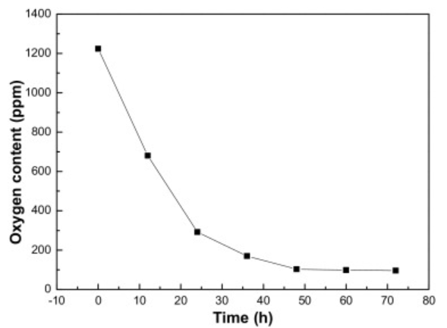
Figure 1. Oxygen content vs purification time for 5L of FLiNaK at a liquid height of 0.9m, at 650°C, at a gas flowrate of 800mL/min [30].
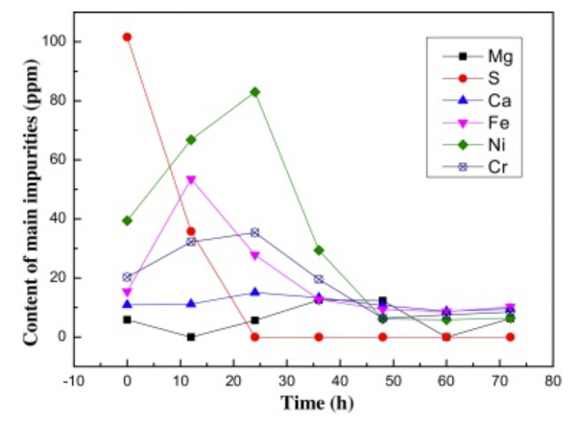
Figure 2. Other impurity content vs purification time for 5L of FLiNaK at a liquid height of 0.9m, at 650°C, at a gas flowrate of 800mL/min [30].
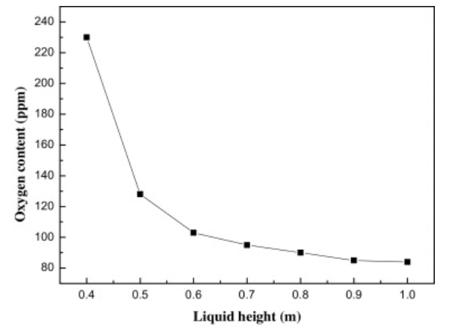
Figure 3. Oxygen content vs liquid height for 5L of FLiNaK run for 48hr at 650°C, at a gas flowrate of 800mL/min [30].
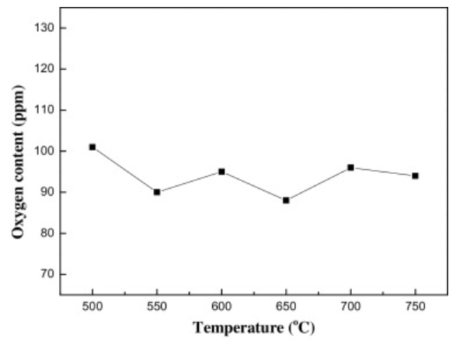
Figure 4. Oxygen content vs temperature for 5L of FLiNaK run for 48hr at a liquid height of 0.9m, at a gas flowrate of 800mL/min [30].
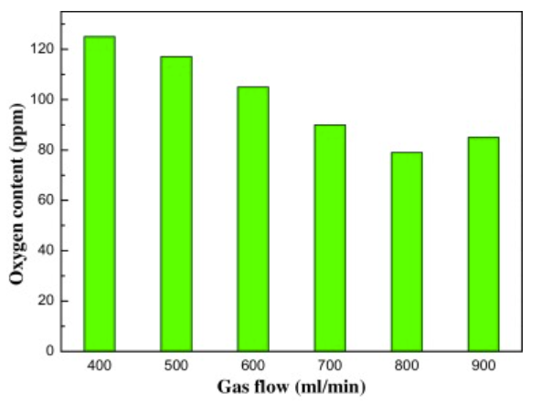
Figure 5. Oxygen content vs gas flowrate for 5L of FLiNaK run for 48hr at a liquid height of 0.9m, at 650°C [30].

Figures 1 & 2 shows that, all other factors being at their optimal state, there is no appreciable change in the concentrations of any of the impurities after roughly 48 hours of hydrofluorination. This implies that running for any longer than this time is pointless so long as the system is optimized and gives a rough maximum for hydrofluorination time. Figure 3 shows that, all other factors being at their optimal state, the relationship between temperature and rate of oxide removal is weak and relatively flat. This is likely due to the increased gas residence time in cooler, more viscous salt offsetting the drop in rate constant caused by a decrease in temperature [30]. Figure 4 shows that, all other factors being at their optimal state, there is an optimal gas flowrate to maximize the rate of oxide removal, in this case, at 800mL/min. This flowrate likely allows for the optimal mix of HF and salt to maximize reaction rate. How these factors change with respect to the amount of salt being produced has not been explored; however, it is assumed to be linear.

4.1.3 Reagent Properties and Hazards
Anhydrous HF is a clear, highly corrosive liquid/gas at room temperature with a boiling point at 19.5°C. HF is also highly toxic (4 on NFPA diamond). It can react with certain metals to release toxic and flammable gases. When it contacts water, hydrofluoric acid is formed, which is even more corrosive. Though not carcinogenic, it can cause severe acid burns if contacted with skin and severe lung inflammation and damage if inhaled. Because of its relatively high boiling point, HF can also present a clogging hazard in thin, unheated lines [31].

4.1.4 Reagent Costs
The upfront costs of HF are relatively low, but due to its relatively high boiling point, trace heating on lines is necessary to minimize clogging issues. Its high corrosivity also means that structural elements will likely need to be replaced occasionally.

4.2 NF₃-H₂ Sparging/NF₃ Baking
Although it has never been used before, NF₃ has several theoretical benefits over HF as a fluorinating agent, and thus may be a viable replacement. NF₃ lack of use means that there is no experimental data to compare, so simulations by Scheele et all are the only source of data. This also means that there is no known preference for using NF₃ with molten or solid salt.

4.2.1 Chemistry and Thermodynamics
Equations 15 and 16 show the general reaction format for the reaction between HF₃ and a component salt oxide and hydroxide, respectively.
$$3yX_{y}O+2NF_{3}→3yXF_{3-y}+N_{2}+1.5O_{2} (15)$$
$$3(3-y){X\left(OH\right)}_{y}+2NF_{3}→3(3-y)XF_{y}+N_{2}+3H_{2}O+1.5O_{2} (16)$$
As demonstrated by Scheele et all [9] NF₃ is a more thermodynamically effective fluorinator than HF, as it has a lower Gibbs free energy of reaction, for every major oxide and hydroxide contaminant formed with the component salts in FLiNaK and FLiBe. The use of NF₃ also introduces the possibility of removing TRISO fuel components from molten salts as it can fluorinate C and UO₂, unlike HF, a difference that could prove useful for commercial uses as TRISO fuel continues to be used more and more in other reactor designs. TRISO particles could be dissolved in the salt as a fuel source. This does imply that NF₃ can potentially be used for in-line purification. As stated previously no data has been found for the general reaction between NF₃ and sulfide, sulfate, or structural metal contaminants. The Gibbs energies of reaction between NF₃ and the oxides of component salts, and between HF and the component salts are shown in Tables 2-9 [31]. The Gibbs energies of the reaction between NF₃ with fuel components and HF with fuel components are shown in tables 10-12 [31].
Table 2. NF₃ + BeO and HF + BeO Gibbs energies of reaction [31].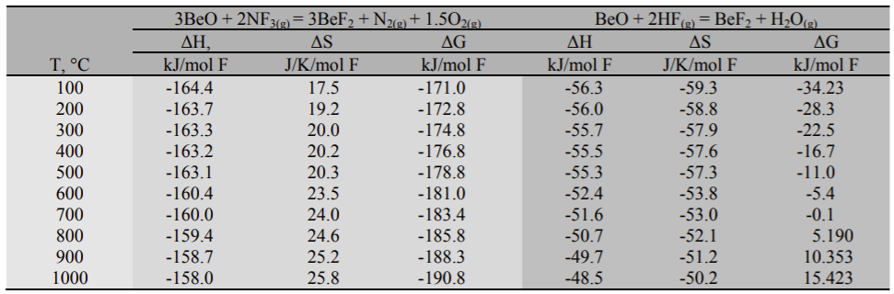
Table 3. NF₃ + Li₂O and HF + Li₂O Gibbs energies of reaction [31]. 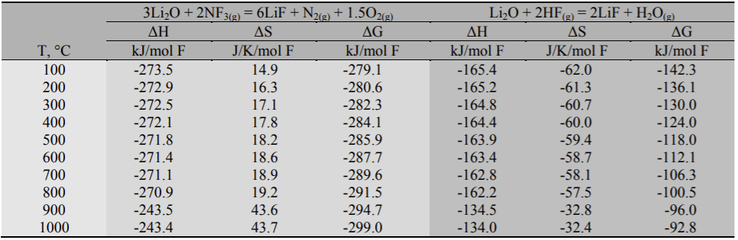
Table 4. NF₃ + Be(OH)₂ and HF + Be(OH)₂ Gibbs energies of reaction [31]. 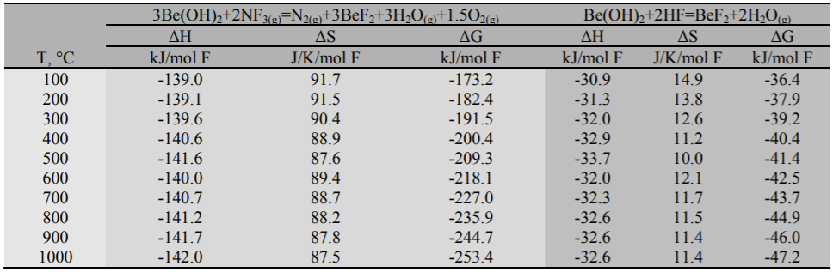
Table 5. NF₃ + LiOH and HF + LiOH Gibbs energies of reaction [31]. 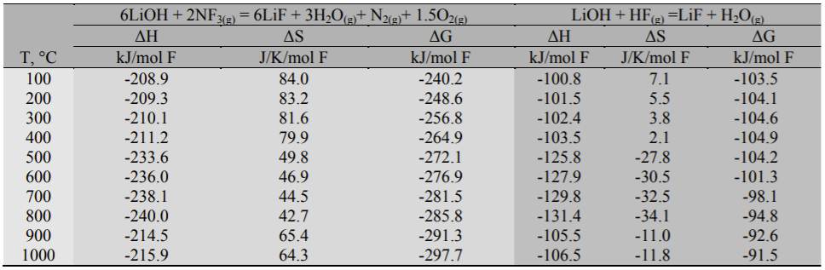
Table 6. NF₃ + Na₂O and HF + Na₂O Gibbs energies of reaction [31]. 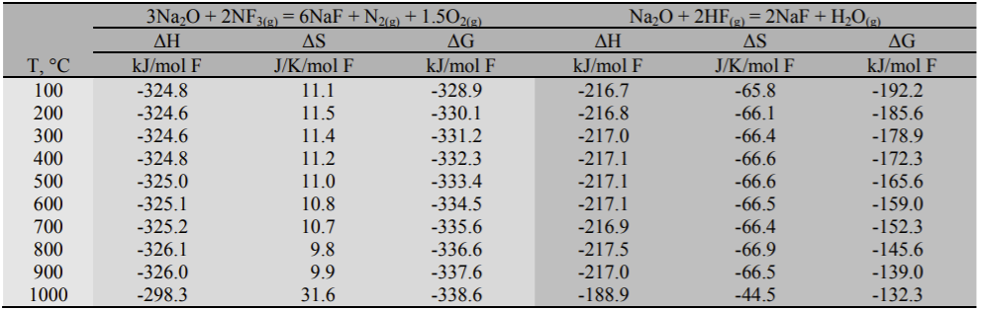
Table 7. NF₃ + K₂O and HF + K₂O Gibbs energies of reaction [31]. 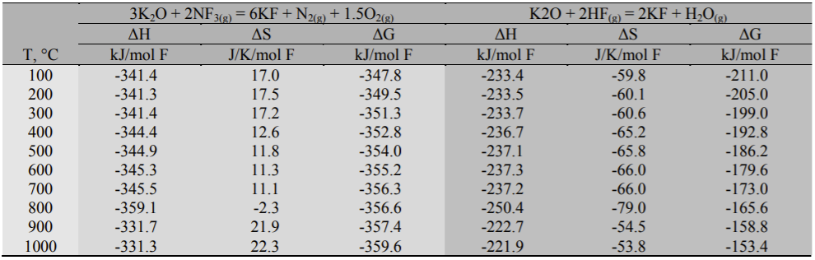
Table 8. NF₃ + NaOH and HF + NaOH Gibbs energies of reaction [31]. 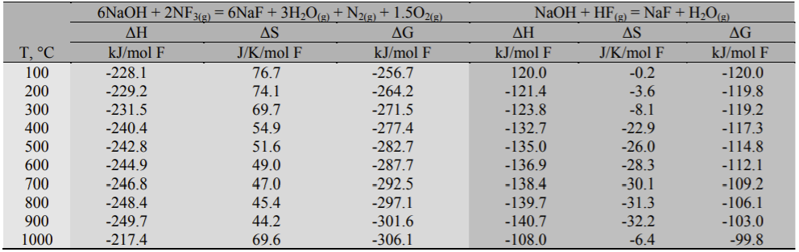
Table 9. NF₃ + KOH and HF + KOH Gibbs energies of reaction [31]. 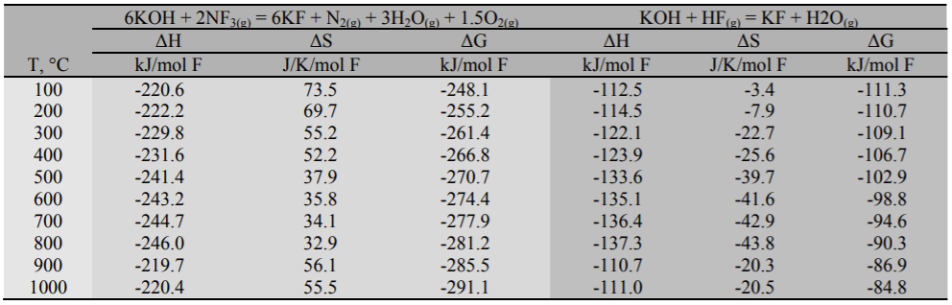
Table 10. NF₃ + UO₂ and HF + UO₂ Gibbs energies of reaction [31]. 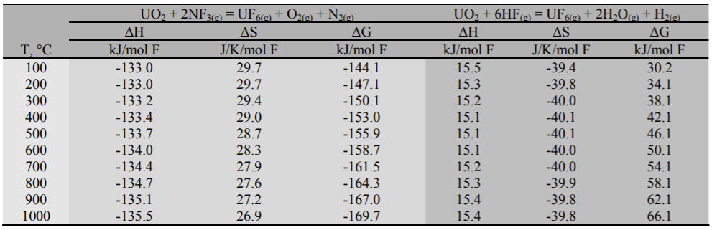
Table 11. NF₃ + C and HF + C Gibbs energies of reaction [31]. 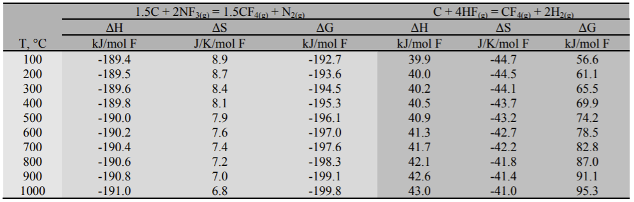
Table 12. NF₃ + SiC and HF + SiC Gibbs energies of reaction [31]. 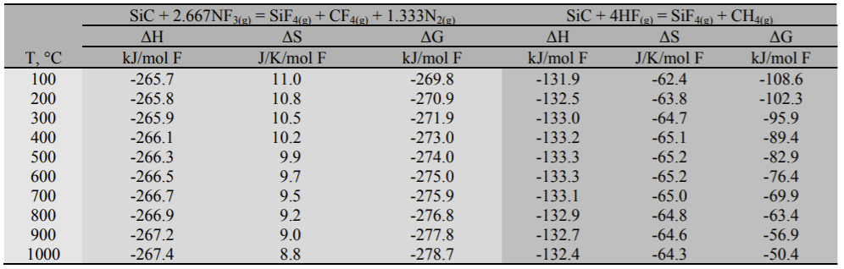

4.2.2 Kinetics
No kinetic data is available for NF₃ purification of molten salt; however, its likely lower solubility in molten salts when compared to HF presents an issue [40]. The salt viscosity needs to be optimized to maximize residence time of the NF₃ in the salt, while also still allowing the NF₃ to diffuse through the salt without becoming trapped. NF₃ also reacts in multistep processes with some compounds which could lead to competing reactions [31], [40]. An example of this is UO₂ to UF₆ by NF₃. The U will first change oxidation states from U⁴⁺ to U⁶⁺ and form UO₂F₂ before turning into UF₆ [31]. Changing oxidation states requires higher temperatures than theorized and can be rate limiting. Further study into the reactions between NF₃ and the various compounds present is necessary to determine which ones are a multistep process.

4.2.3 Reagent Properties and Hazards
At lower temperatures, NF₃ is a colorless gas, with oxidizing properties similar to that of oxygen gas; however, at temperatures exceeding 400°C, NF₃ decomposes to form fluorine radicals and behave more like fluorine gas [31]. Because of this, more noble alloys (such as Ni-200, Hastelloy-N, Monel 400, etc.) are required for resisting the high corrosivity of NF₃ at high temperatures [31]. NF₃ is also considered a significant greenhouse gas, as it has a global warming potential that is 10800 times that of CO₂ [41], and will possibly become a regulated gas, requiring a recycling system to be used [31]. The physical properties of NF₃ are shown in Table 13 [31].
Since the reactivity of NF₃ is dependent on its temperature, it may be preferable to bake the salts at a lower temperature under a continuously flowing NF₃ atmosphere. This could potentially allow for a pure NF₃ flow (as opposed to it being diluted by hydrogen) but would be even more limited by the diffusion of NF₃ into the solid salt crystal structure.
Table 13. Physical Properties of NF₃ [31].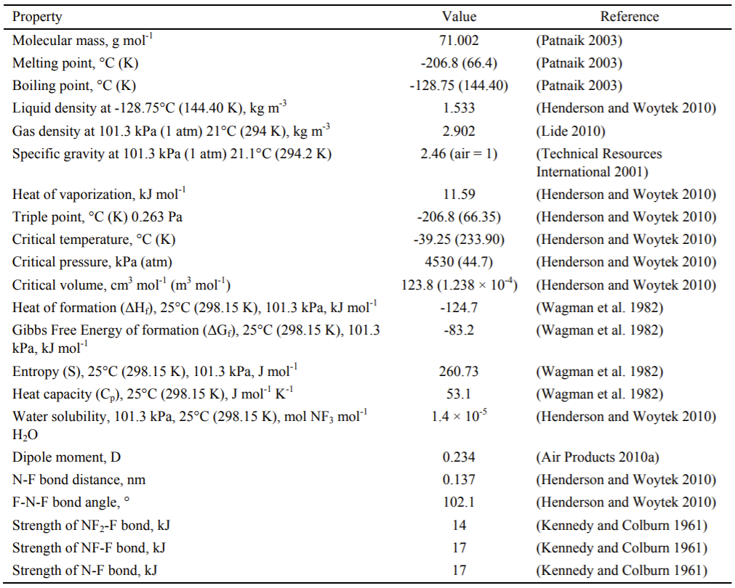

4.2.4 Reagent Costs
For a lab grade purchase, NF₃ will cost roughly 2.5-3 times as much as HF [31]. Factoring in the possible cost of NF₃ recovery could further increase the cost of NF₃ compared to that of HF; however, because it is not as nearly corrosive, and is a gas at room temperature, heat tracing and noble alloy piping and fittings are not required to transport unheated NF₃. This could offset some of the aforementioned costs compared to HF.

4.3 NH₄HF₂ Baking
Another available method for molten salt purification is NH₄HF₂ baking. This process involves the addition of high purity NH₄HF₂ to the frozen salt mix. This mixture is then placed in a sealed container and brought up to 600C-750C for 4-24 hours after which the container is purged with an inert gas opened in an inert, dry atmosphere to collect the purified salt [42].

4.3.1 Chemistry
Above 230C, NH₄HF₂ decomposes via the reaction shown in equation 17 [16].
$${NH}_{4}{HF}_{2} →{NH}_{3}+2HF (17)$$
The NH₃ produced in this reaction is inert relative to the salt and its impurities; however, the HF produced reacts in the same manner as what was shown in section 3.1.1. Since this method relies on the produced HF to react with the salt’s impurities, its thermodynamics are the same as those for HF shown in tables 2-10.
This method will not purify the salt to the same extent as HF-H₂ sparging. HF-H₂ sparging will bring the oxygen content down to ~80 ppm [16], [30], while NH₄HF₂ baking will only bring oxygen content down to ~200 ppm [43], with all other contaminants being at about equal concentrations for both methods, besides sulfates which require a reaction with H₂ as shown in equation 10, meaning NH₄HF₂ baking will not remove this contaminant. This shorter extent of purification could be explained by a number of factors, but I believe that this is likely due to a lack of replenishment of the HF supply for the reaction.

4.3.2 Kinetics
This method can reach 200 ppm oxygen much faster than HF-H₂ sparging. While no studies into the kinetics of this method could be found, a rough time of 24 hours was claimed to be sufficient to reach 200 ppm [42], [43]. As shown in figure 1, Zong et all found that oxygen content was around 300 ppm after 24 hours for an optimized setup [30]. This may be due to increased contact between the HF and oxygen contaminants in NH₄HF₂ baking due to the dispersal of NH₄HF₂ in the salt prior to heating as opposed to the limited diffusion resulting from HF-H₂ bubbling through the molten salt.

4.3.3 Reagent Properties and Hazards
At room temperature NH₄HF₂ takes the form of white crystals. This allows it to be ground and mixed with salt eutectics at room temperature and loaded into the reaction vessel all at once. While dangerous if ingested or absorbed through the skin it presents no other harm in its solid state. Primary hazards associated with this method are due to the HF produced upon heating of the NH₄HF₂. Treatment of reaction effluent is the same as HF-H₂ sparging. Corrosion of the reaction vessel is less of a concern with this method than with HF-H₂ sparging due to the lower concentration of HF and the reduced exposure time. While less effective than the aforementioned methods this method allows for a simpler reactor setup and drastically decreased risk to health.

4.4 Electrolytic Purification
A separate method of purification can be found in electrolysis of the molten salt mix. This method does provide a couple of advantages versus chemical purification. Electrolytic purification is both faster and less wasteful than chemical purification and releases considerably less toxic off gas. It is, however, less complete than chemical purification, with oxide concentrations only going as low as ~200 ppm with just electrolysis [44]. It also cannot remove all metal impurities from the salt. Cr in particular will remain in solution as CrF₂.
As stated previously, the first experiments for using electrolysis to purify molten fluoride salt were done as part of the ARE in late 1954 [5]. They used an electrolytic cell containing a graphite rod anode and a nickel mesh cathode to help drop the fluorination potential of salts by reducing dissolved metal fluorides to their metallic form and releasing fluorine gas, which would be converted to hydrogen fluoride by reacting with a padding hydrogen blanket above the salt [5]. Equations 18 and 19 show the reaction pathway. This method was introduced as a faster way of reducing the fluorination potential of the salt compared to pure hydrogen sparging and showed promise but was never introduced into the production process and quickly dropped for unspecified reasons. This could be due to issues found with the method, a lack of want to modify existing purification equipment at the time, or advantages associated with using reducing agents to help accelerate fluoride reduction instead.
$$MeF_{2}\left(aq\right)\underset{→}{electrolyis} Me\left(s\right)+F_{2}\left(g\right) (18)$$
$$H_{2}+F_{2}→2HF (19)$$
Experiments by Wang et all have re-opened the possibility of using electrolytic means to purify molten salts [44]. The results of their experiments showed that a C, Ni electrode could be used to reduce the oxide concentration in an unspecified amount of FLiNaK down from 1000 ppm to around 200 ppm in a matter of 20 hr. They also showed a reduction in several metal contaminants.
Very recently, a molten fluoride salt electrolytic purification experiment was performed by Zuo et all [27]. Their experiment focused on improving the performance of electrolytical purification methods through the addition of a continuous hydrogen sparge to the electrolytic setup. Their cell design is shown in Figure 6.A nickel tube of flowing hydrogen gas is lowered into a nickel crucible filled with molten salt, and electrodes are connected to the tube and crucible, effectively creating a H⁺/H₂, Ni electrode instead of the C, Ni electrode used during the ARE experiments. A nickel foil was used to increase the surface area of the nickel electrode. This setup was able to get an unspecified amount of FLiNaK salt down below 100 ppm of oxygen contaminants in just a couple of hours. The hydrogen sparge would also cause Ni and Fe impurities to be somewhat reduced out of solution. Issues with scaling up this process were brought up, namely that the current through the salt is low, presenting a potential size limit for a given voltage.
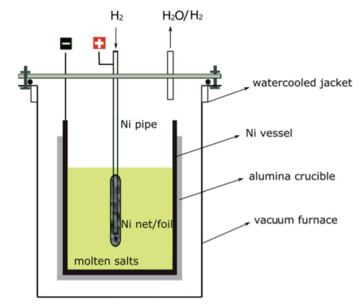
Figure 6. Molten salt electrolytic purification vessel design used by Zuo et all [27].
Although no prior studies had been performed to determine the effectiveness of electrolytic purification of a fluoride salt, there had been studies undertaken and methods developed for purification in some chloride salts [32], [45], [46]. Ding et all have produced complex, proven electrolytic cells for the monitoring and purification of Mg bearing chloride salts [45]. A diagram of the purification setup is shown in Figure 7. By using a sacrificial Mg anode and a W cathode, hydroxides in the melt were reduced to MgO, and the concentration of corrosive hydroxides in the melt was reduced by 93% in a matter of a few minutes. The kinetics of this type of electrochemical cell are limited by the buildup of a passivation layer on the cathode. This effect can be mitigated by substituting the W used in the cathode for Mg and using alternating voltage to periodically swap the direction of electron flow [46].
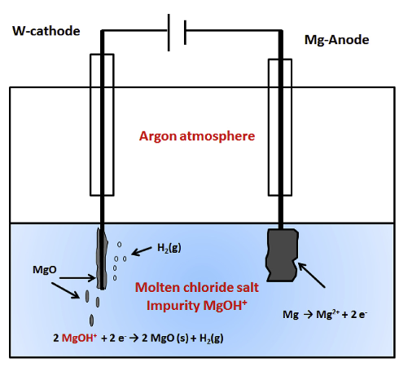
Figure 7. Molten chloride salt purification mechanism by Ding et all [45].
The limited amount of research into this area presents a challenge and an opportunity. From the beginning, electrolytic purification setups have always been modifications to existing hydrofluorination setups so modifying existing designs would likely not be difficult. Plenty of research exists for using electrolytic salts to purify other metals, but little exists for purifying the salts themselves.

5. Additional Steps
Although hydrofluorination is the main step for purifying molten fluoride salts, additional refinement is necessary to ensure the highest purity. Corrosion during the hydrofluorination process will cause structural materials to become fluorinated and dissolve into the molten salt mix. Some HF will also be dissolved into the salt and will need to be removed to reduce the corrosive properties of the salt mix.

5.1 Continued H addition
A common method of continuing to sparge the mix after fluorination with just H₂ gas will reduce some of the less favorable structural metal fluorides from the mix. The reduced metal can be left to settle to the bottom of the molten salt mix and then be decanted off or left suspended in the mix and filtered. This can take an additional several dozen hours depending on just how much of the reaction or storage vessel is corroded away into the salt. For Kelleher et all this step took 36 hours as their salt had been highly contaminated after years in a metal storage vessel [16], [29].
An alternative means of adding hydrogen to the system is in the form of metal hydrides, notably lithium hydride (LiH). This is a more efficient means of adding hydrogen to the system, as hydrogen concentrations in the melt can be as much as 4 degrees of magnitude higher with LiH powder additions than with H₂ gas sparging [47]. This allows the salt to be brought to a highly reducing state, to the point that salt constituent metals, like Be in the case of FLiBe or potentially K and Na in the case of FLiNaK (no research data found only theoretical), will reduce to their metallic forms, and form molten pools on the surface of the salt, as shown in Figure 8 [48].
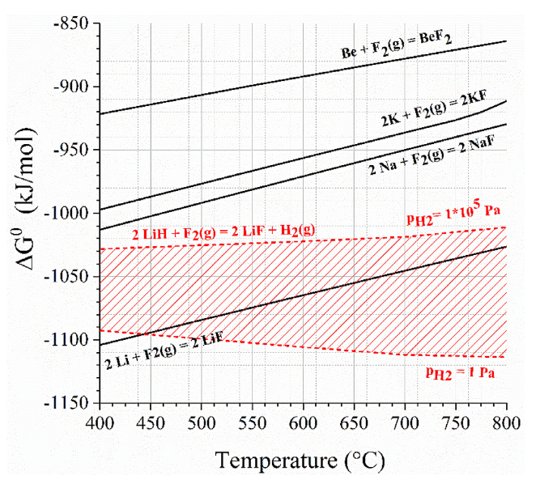
Figure 8. Ellingham diagram of the expected redox window from Carotti et al [48].
This could cause drastic changes in the relative concentrations, bringing the salt mix away from the eutectic, and has been shown to cause shorting in electrochemical processes performed in the salt [48]. If properly accounted for however, this could be a practical alternative in purification processes that avoid any gas sparging.

5.2 Reducing Metal Additions
The use of a small amount of a strong reducing metal such as Be or Zr can be used to effectively reduce out the HF by forming BeF₂ or ZrF₄. This can also be used to reduce out less favorable structural metal fluorides [16], [21], [29]. Cr in particular will not reduce out through just hydrogen sparging. This is best done in combination with H₂ sparging since the flow of gas through the salt will have a mixing effect. This method also has the adverse effect of adding contaminants to the salt. This is less of an issue for FLiBe since adding Be metal will just create more BF₂ for the solution, however the change in concentration still needs to be considered. The reduced metal can be left to settle to the bottom of the molten salt mix and be decanted off or left in suspension and filtered off.

5.3 Filtration
As stated previously the need to wait for reduced metals to settle to the bottom of the molten salt mix can be avoided through filtration during hot transfer. This was the method used by the MSRE [21] and Kelleher et all [16], [29]. This method is more effective at removing reduced structural metal particulates from the salt mix than decanting; however, it does come with one major issue: clogging. The small pore size necessary to remove metal particulates and high freezing point of the salts makes clogging a hard issue to avoid. This was a frequent and persistent issue for both the MSRE [21] and Kelleher et all [16], [29]. Because of this heat trace and maximizing filter surface area are both necessary additions. Woven mesh filters are also preferable over sintered filters.

6. Corrosion in Structural Materials
The highly corrosive properties of both the hydrofluorinating reagents and the molten salt itself requires a balance between process safety and cost management. High nickel alloys are far more resistant to corrosion by both than stainless steels; however, they are also far more expensive [49]. This means that for practical applications, an acceptable rate of corrosion needs to be established.

6.1 Corrosion Due to Hydrofluorinating Reagents
The corrosion mechanism of structural metals by HF is shown by Equation 12. Corrosion occurs by the fluorination of pure metals to metal fluorides, which can be more easily dissolved into the salt solution. Both HF-H₂ sparging and NH₄HF₂ baking use HF as the primary hydrofluorinating agent. Reversing the directions of Equations 9, 10, and 13 also show that HF is produced as a by-product of salt contamination. Figure 6 shows the Gibbs free energy of formation for various elemental metal fluorides.
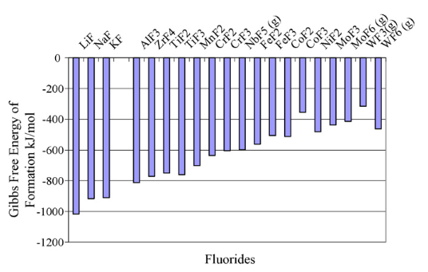
Figure 9. Gibbs Free Energy of Fluorination of Various Elemental Metals [33].
NF₃ corrodes structural metals via the same mechanism as HF: fluorination; however, as stated previously, it is more aggressive than HF at elevated temperatures [31]. No corrosion data exists for NF₃ or any analogous gas, such as fluorine, near expected process temperatures. This is likely due to the extreme health risks and financial costs associated with running such an experiment.
Because their fluorination potential is higher than that of Ni, Cr and Fe are more easily corroded in a fluorinating environment and should therefore be reduced as much as possible. Cr has an especially high fluorination potential, causing it to be targeted for attack first (if present) for most applicable alloys [24], [33], [34], [38], [50], [51]. This high fluorination potential can be and counteracted by diluting the fluorinating agent with a reducing gas, namely H₂. The effects of a high fluorination potential can also be reversed by dropping the fluorination potential of the salt mix, by removing excess fluorine ions from the mix, using a reducing agent such as an active metal or H₂ sparging.

6.2 Embrittlement Due to Hydrogen
Although not a direct contributor to corrosion, exposure to H₂ can cause embrittlement by infiltration into the metal’s grain boundaries. H₂ can build up along grain boundaries, exerting pressure on and deforming the grains to reduce ductility and strength. This has the added effect of increasing the size of grain boundaries, allowing for increased attack by corrosive agents.
For annealed metals, increasing the Ni content tends to increase resistance to hydrogen ingress affecting structural strength; however, for cold worked metals this trend is reversed [52], [53]. Increasing the Ni content also causes an increase in intragranular fracture due to hydrogen embrittlement, as depicted in Figure 7.

Figure 10. Microstructure of annealed 316L stainless steel before (a) and after (b) 20 hr of cathodic hydrogen charging compared to annealed Hastelloy C-276 before (c) and after (d) 20 hr of cathodic hydrogen charging [53].
This increase in crack size and frequency in higher Ni alloys would likely allow for more surface to be attacked by corrosive agents; however, the higher Ni content likely more than offsets this through its higher fluorination resistance.

6.3 Corrosion Due to Molten Salt
There are essentially 2 theorized methods of corrosive attack by molten salt on structural metals: continuous corrosion due to mass transfer of metals into the salt and impurities in the salt mix [54].
Across the MSRE project, samples of the coolant FLiBe salt were taken to measure the concentration of Cr, Fe, and Ni dissolved into the salt as a method of determining the rate of corrosion of the Hastelloy-N piping by the salt. Analysis of these samples showed that, while there was an initial spike in metal concentration (thought to be due to reactions caused by impurities in the salt), the metal concentration leveled off at 32 ppm Cr, 64 ppm Fe, and 20 ppm Ni. These values persisted allowing for the time between samples to be taken monthly and did not spike again until the system had become contaminated due to atmospheric exposure [54]. These findings imply that continuous corrosion due to mass transfer is minimal, if not nonexistent, at least for FLiBe with Ni alloys. These tests were however performed in static tests with a constant bulk temperature throughout. Future testing conducted by Santarini at Oak Ridge National Lab found that there was sustained corrosion in the MSRE due to the existence of a temperature gradient in a flowing molten salt loop which caused an imbalance in the concentration of Cr²⁺ in the salt solution [55]. Cr²⁺ would build up in colder sections of the loop, causing more Cr to diffuse into the salt at the hotter sections [55]. This phenomenon has since been confirmed in other experiments, using other metal alloys [23], [35], [36].
Complete purity is not practically attainable, due to all purification methods described above being equilibrium reactions. Despite this corrosion tests have been performed with salt purified to a reasonable extent. Raiman et all has compiled results from these tests into a series of graphs shown in Figures 8-10 [34].
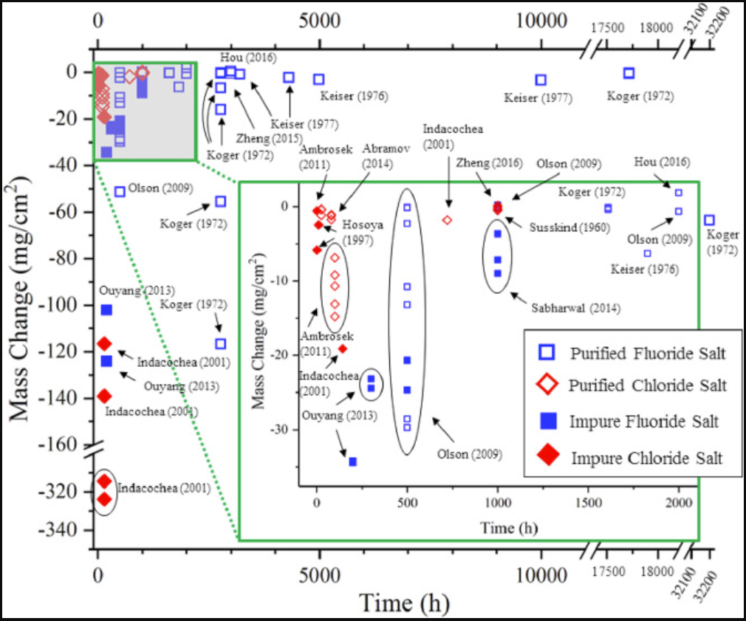
Figure 11. Aggregation of corrosive mass change over time for purified and non-purified fluoride and chloride salts across various tests [34].
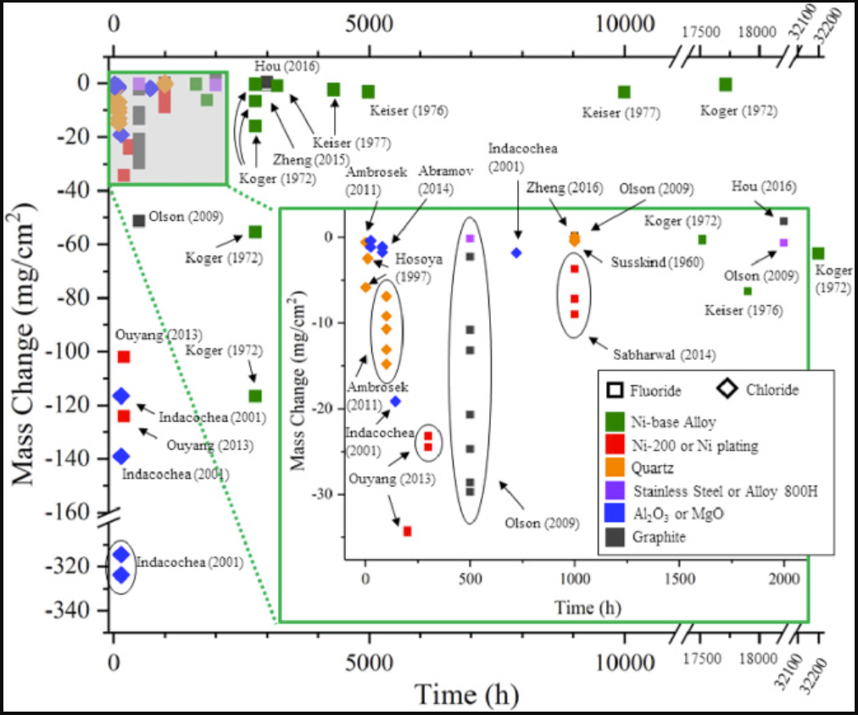
Figure 12. Aggregation of corrosive mass change in various materials over time for fluoride and chloride salts across various tests [34].
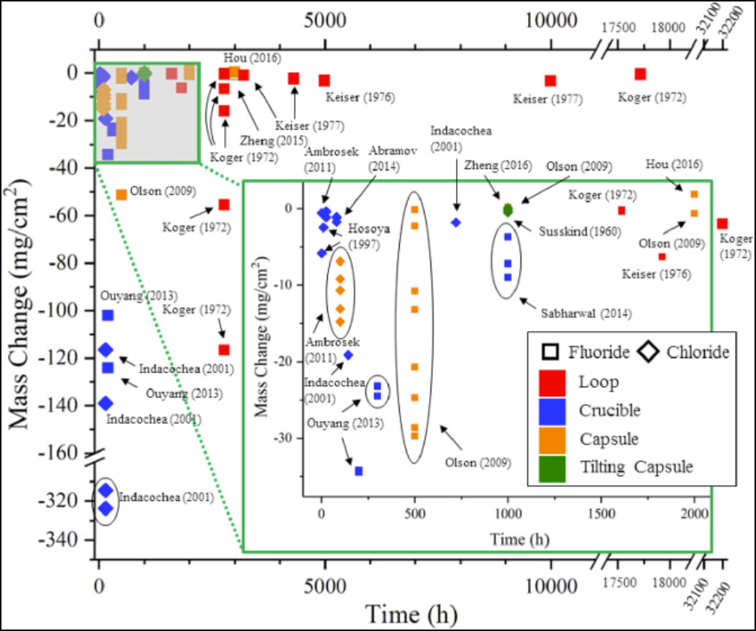
Figure 13. Aggregation of corrosive mass change in over time for fluoride and chloride salts across various tests using various methods [34].

Results of this aggregation of data show that there is a wide variance in the reported corrosion rate of nickel-based alloys and very little data for the corrosion rate of stainless steels in crucible and loop tests.
Just like with other forms of fluorination, Fe and Cr will be corroded before Ni. The trend for these metals to be targeted before Ni is demonstrated by Figure 9, where almost pure Ni experienced miniscule corrosion compared to other alloys with higher Cr and Fe compositions [33].
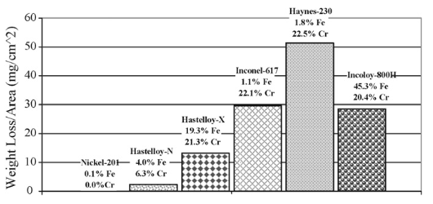
Figure 14. Corrosion of Various Nickel Alloys from 500 hr exposure to 850C FLiNaK [33].
These results indicate that any structure with frequent direct exposure to molten fluoride salt should be as low in Cr and Fe content as possible while containing high levels of Ni content.

6.4 Corrosion Due to Added Fuel
The fluorination potential of fuel metals such as U and Th is lower than that of Cr. This causes Cr to be selectively fluorinated and therefore corroded by the process shown in Equation 18 [51].
$$2{UF}_{4} + Cr ⇆ 2{UF}_{3}+ {CrF}_{2} \left(18\right)$$
Because Equation 18 goes to equilibrium, the rate of corrosion due to fuels can be controlled by controlling the ratio of UF₄ to UF₃ in the salt mix. Surenkov et all found this ratio to be around 30-40. Tests by the MSRE on specific attack of Cr in Hastelloy-N by fuel enriched salt found the diffusion coefficient of Cr into the salt mix to max out at around 4 X 10⁻¹⁴ cm/sec at 650°C; however, issues caused by the method of obtaining this value leads it to be less widely accepted [54], [56]. A more widely accepted value of 8 X 10⁻¹⁵ cm/sec at 650°C was found by Watson et all [57].
It is noteworthy however, that having some Cr dissolved in the salt is essential to prevent corrosive attack on other metals by the fission product Te, as shown by Equation 19 [56].
$$2{UF}_{3} + CrF_{2} +Te ⇆ 2{UF}_{4}+ CrTe \left(19\right)$$
This causes a stable CrTe compound to fall out of solution. Keiser et all found that this process would prevent the attack of other structural metals by Te for a UF₄/UF₃ ratios below 80 [58]. Therefore, there is some merit to allowing the UF₄/UF₃ ratio to be more reducing. It is also worth noting that Fe and Cu based alloys have an increased resistance to Te intergranular attack compared to Ni based alloys [59].

7. Compatibility of Candidate Structural Materials
As stated previously, pure molten fluoride salts have very little to no corrosive effects. This is due to the Gibbs energy of fluorination being more favorable for the salt components (i.e. K, Li, Na, and Be) than for structural materials (i.e. Fe, Cr, Ni, etc.). However, the presence of contaminants, either through environmental contamination or fission products, will skew the redox potential of the salt such that corrosion of structural materials will occur. While the purification methods listed above can be used to minimize the concentration of environmental contaminants (and even fission products in the case of NF3), they only work so well, making selection of proper materials necessary.

7.1 Ni Alloys
The simplest thing to do is select materials whose fluorination potential is as far from the salt components as possible. To this end alloys made of primarily Ni or Mo are practical, since they are the materials that have a high Gibbs energy of fluorination and can be easily welded. Since Ni is the cheaper of the two metals it will be focused on [49]. While pure Ni (Ni-200) would likely be the material of choice from a pure chemistry standpoint, its poor structural strength at process temperatures (>500C) makes its use limited. The MSRE used pure Ni liners in their purification vessels, and although these corroded away when fluorine gas was used to purify used salt, the concept is still sound [21]. It simply requires more active checking the liner between runs. Kelleher et. all used a pressurized outer shell made of steel to add structural strength to their Ni-200 purification vessel [29].
Ni alloy Hastelloy N (also known by INOR-8) is another appealing option that has a lower but comparable corrosion resistance to Ni-200, due to its high Ni and Mo content, with increased structural strength due to small concentrations of W, Fe, and Cr [50], [51]. Hastelloy N was specifically made for the MSRE and was used as the sole structural material in the MSRE loop [51]. It showed almost no corrosion across the entire run [51]. Experimental data obtained by Koger predicted the corrosion rate of Hastelloy N by dynamic FLiBe to be at around 0.02 mil/year [36]. Experiments by Sandhi et all showed Hastelloy N to have a high resistance to corrosion by static, molten FLiNaK salt [37]. In their experiments, Hastelloy N apparently suffered less surface corrosion, had a lower surface concentration of Cr, half the depth of surface penetration, and had a positive mass change after spending 100 hr in 700°C FLiNaK, when compared to stainless steel [37]. Hastelloy N’s use in a purification vessel is largely unproven, however its resistance to anhydrous HF and molten salts has been explored, and it proved to have a low rate of corrosion compared to other high Ni alloys with a largely linearly changing corrosion rate with temperature [37], [50], [51].

7.2 Steels
Steels due to their high structural strength at high temperatures and lower cost should be at least considered. The main issue with most commercial stainless steels is their high Cr content, but Fe is also more easily fluorinated than Ni or Mo. If salts are sufficiently purified then corrosion can be mitigated in a molten salt loop, although as low of a chromium content as is possible is preferred. Steels however cannot be used for creation of a purification vessel that utilizes HF or any stronger fluorinating agent as it will corrode too quickly. Stainless steels can handle low temperature HF, but they will not handle it at process temperatures [50]. For stronger fluorinating agents like fluorine gas or higher temperature NF₃, all steels are considered to have an unacceptable rate of corrosion [50].

7.3 Copper
A material that also historically has showed much promise is copper. When scaling up to meet the high demands for purified salts, the ARE swapped out their nickel reaction vessels for stainless steel vessels lined with copper [6]. This vessel design remained in intermediate use with nickel lined vessels through to the conclusion of the MSRE [10], [28]. They later made sampling vessels out of copper as well. During the MSRE, when the nickel dip tubes corroded away, likely due to the high sulfur content of received salt, attempted solutions involved coating the nickel parts with copper [28]. After the MSRE, the use of copper in fluorination appears to have stopped, with studies into its corrosion in molten salt environments only just recently resuming [60]. Despite this, a recent study by Weinstein et. all has shown copper to have superior corrosion resistance with inferior chromium diffusion resistance to nickel [60]. Further studies into this may become available soon. The main issue with this as a material is that, while copper is highly resistant to dry fluorinating agents, it is readily corroded and dissolved by hydrofluoric acid, so moisture must be purged readily to prevent serious corrosion [6].

7.4 Carbon
Although not mechanically useful, glassy carbon, graphite, and SiC do make for excellent crucible/liner materials in a reaction vessel, since carbon is chemically inert to all but the harshest fluorinating compounds (such as F₂ and NF₃) [31], [61]. The main issues of using carbon structures are that salt can diffuse into the graphite [62] and the increase in the corrosion of metals used in other structures [63], [64]. Molten salt impregnation of graphite is a well-documented phenomenon first observed in early ARE materials tests [61], [65]. Depending on the pore size and void fraction of the graphite, salt impregnation can cause serious structural damage to the graphite via cracking, particularly during the frequent cooling and heating cycles of a purifier [62]. This makes glassy carbon the preferred material to use over even high-quality graphite. The increase in salt corrosivity due to graphite contamination is a less understood phenomenon however it was discovered to occur in the MSRE test loops [63]. The exact transport mechanism of this phenomenon is unknown and is currently under study; however, it is understood that the carbon and metal particles do diffuse through the salt to form carbide layers on both surfaces and that the formation of carbide layers on metal surfaces is normally prevented by protective oxide layers on the metals, which are destroyed in a molten salt or fluorinating environment [64]. These carbide layers can flake off and expose fresh metal surfaces to be further carburized.

8. References
[1] R. C. Briant and A. J. Miller, “Aircraft Nuclear Propulsion Project Quarterly Progress Report for Period Ending March 10, 1952,” Oak Ridge National Lab, Progress Report ORNL-1227, Mar. 1952. [Online]. Available: https://github.com/openmsr/msr-archive/blob/master/docs/ORNL-1227.pdf
[2] R. C. Briant, J. H. Buck, and A. J. Miller, “Aircraft Nuclear Propulsion Project quarterly progress report for period ending June 10, 1952,” Oak Ridge National Lab, Progress Report ORNL-1294, Jun. 1952. [Online]. Available: https://github.com/openmsr/msr-archive/blob/master/docs/ORNL-1294.pdf
[3] R. C. Briant, J. H. Buck, and A. J. Miller, “Aircraft Nuclear Propulsion Project Quarterly Progress Report for Period Ending December 31, 1952,” Oak Ridge National Lab, ORNL-1439, Jan. 1953. doi: 10.2172/1232654.
[4] R. C. Briant, J. H. Buck, and A. J. Miller, “Aircraft Nuclear Propulsion Project quarterly progress report for period ending March 10, 1953,” Oak Ridge National Lab, Progress Report ORNL-1515, Apr. 1953. [Online]. Available: https://github.com/openmsr/msr-archive/blob/master/docs/ORNL-1515.pdf
[5] W. H. Jordan, S. J. Cromer, R. I. Strough, and A. J. Miller, “Aircraft Nuclear Propulsion Project Quarterly Progress Report for Period Ending December 10, 1954,” Oak Ridge National Lab, Progress Report ORNL-1816, Jan. 1955. [Online]. Available: https://github.com/openmsr/msr-archive/blob/master/docs/ORNL-1816.pdf
[6] W. H. Jordan, R. I. Strough, S. J. Cromer, and A. J. Miller, “Aircraft Nuclear Propulsion Project Quarterly Progress Report for Period Ending September 10, 1955,” Oak Ridge National Lab, Progress Report ORNL-1947, Oct. 1955. [Online]. Available: https://github.com/openmsr/msr-archive/blob/master/docs/ORNL-1947.pdf
[7] H. G. MacPherson, “Molten-salt Reactor Program quarterly progress report for period ending October 31, 1957,” Oak Ridge National Lab, Progress Report ORNL-2431, Feb. 1958. [Online]. Available: https://github.com/openmsr/msr-archive/blob/master/docs/ORNL-2431.pdf
[8] H. G. MacPherson, “Molten-salt Reactor Program quarterly progress report for period ending October 31, 1958,” Oak Ridge National Lab, Progress Report ORNL-2626, Jan. 1959. [Online]. Available: https://github.com/openmsr/msr-archive/blob/master/docs/ORNL-2626.pdf
[9] H. G. MacPherson, “Molten-salt Reactor Program quarterly progress report for period ending April 30, 1959,” Oak Ridge National Lab, Progress Report ORNL-2723, 4270021, Jun. 1959. doi: 10.2172/4270021.
[10] R. B. Briggs, “Molten-Salt Reactor Program: Semiannual Progress Report for Period Ending July 31, 1964,” Oak Ridge National Lab, Oak Ridge National Lab, Progress Report ORNL-3708, Nov. 1964.
[11] M. W. Rosenthal, R. B. Briggs, and P. R. Kasten, “Molten-Salt Reactor Program semiannual progress report for period ending February 28, 1969,” Oak Ridge National Lab, Oak Ridge National Lab, Progress Report ORNL-4396, Aug. 1969.
[12] M. W. Rosenthal, R. B. Briggs, and P. N. Haubenreich, “Molten-Salt Reactor Program semiannual progress report for period ending August 31, 1972,” Oak Ridge National Lab, Oak Ridge National Lab, Progress Report ORNL-4832, Mar. 1973.
[13] M. W. Rosenthal, R. B. Briggs, and P. R. Kasten, “Molten-Salt Reactor Program semiannual progress report for period ending February 28, 1970,” Oak Ridge National Lab, Oak Ridge National Lab, Progress Report ORNL-4548, Aug. 1970.
[14] C. D. Scott and W. L. Carter, “Preliminary Design Study of a Continuous Fluorination-Vacuum Distillation System for an Molten Salt Breeder Reactor,” Oak Ridge National Lab, Oak Ridge National Lab, ORNL-3791, Jan. 1966.
[15] M. W. Rosenthal, R. B. Briggs, and P. N. Haubenreich, “Molten-Salt Reactor Program semiannual progress report for period ending August 31, 1971,” Oak Ridge National Lab, Oak Ridge National Lab, Progress Report ORNL-4728, Feb. 1972.
[16] B. C. Kelleher, K. P. Dolan, P. Brooks, M. H. Anderson, and K. Sridharan, “Batch-Scale Hydrofluorination of Li27BeF4 to Support Molten Salt Reactor Development,” J. Nucl. Eng. Radiat. Sci., vol. 1, no. 4, p. 041010, Oct. 2015, doi: 10.1115/1.4030963.
[17] R. Serrano-López, J. Fradera, and S. Cuesta-López, “Molten salts database for energy applications,” Chem. Eng. Process. Process Intensif., vol. 73, pp. 87–102, Nov. 2013, doi: 10.1016/j.cep.2013.07.008.
[18] F. Lantelme and H. Groult, Eds., Molten salts chemistry: from lab to applications, First edition. Amsterdam: Elsevier, 2013.
[19] P. N. Haubenreich and J. R. Engel, “Experience with the Molten-Salt Reactor Experiment,” Nucl. Appl. Technol., vol. 8, no. 2, pp. 118–136, Feb. 1970, doi: 10.13182/NT8-2-118.
[20] J. Mcfarlane, P. A. Taylor, D. E. Holcomb, and W. Poore III, “Review of Hazards Associated with Molten Salt Reactor Fuel Processing Operations,” ORNL/TM--2019/1195, 1543201, Jun. 2019. doi: 10.2172/1543201.
[21] J. H. Shaffer, “PREPARATION AND HANDLING OF SALT MIXTURES FOR THE MOLTEN SALT REACTOR EXPERIMENT.,” ORNL--4616, 4074869, Jan. 1971. doi: 10.2172/4074869.
[22] M. W. Rosenthal, R. B. Briggs, and P. N. Haubenreich, “Molten-Salt Reactor Program semiannual progress report for period ending February 28, 1971,” Oak Ridge National Lab.
[23] Y. Wang, J. Wu, C. Wang, and S. Zhang, “Electrochemical corrosion behavior of 316L stainless steel in molten fluorides with a temperature gradient,” Electrochem. Commun., vol. 109, p. 106612, Dec. 2019, doi: 10.1016/j.elecom.2019.106612.
[24] H. Ai et al., “Effects of O2− additive on corrosion behavior of Fe–Cr–Ni alloy in molten fluoride salts,” Corros. Sci., vol. 150, pp. 175–182, Apr. 2019, doi: 10.1016/j.corsci.2019.01.040.
[25] Gerald. Goldberg, A. S. Meyer, and J. C. White, “Determination of Oxides in Fluoride Salts by High-Temperature Fluorination with Potassium Bromotetrafluoride,” Anal. Chem., vol. 32, no. 3, pp. 314–317, Mar. 1960, doi: 10.1021/ac60159a004.
[26] D. Sulejmanovic, J. M. Kurley, K. Robb, and S. Raiman, “Validating modern methods for impurity analysis in fluoride salts,” J. Nucl. Mater., vol. 553, p. 152972, Sep. 2021, doi: 10.1016/j.jnucmat.2021.152972.
[27] Y. Zuo, Y.-L. Song, R. Tang, and Y. Qian, “A novel purification method for fluoride or chloride molten salts based on the redox of hydrogen on a nickel electrode,” RSC Adv., vol. 11, no. 56, pp. 35069–35076, 2021, doi: 10.1039/D1RA05794D.
[28] L. E. McNeese, “Molten-Salt Reactor Program semiannual progress report for period ending August 31, 1975,” Oak Ridge National Lab, Oak Ridge National Lab, Progress Report ORNL-5078, Feb. 1976.
[29] B. C. Kelleher, “Purification and Chemical Control of Molten Li2BeF4 for a Fluoride Salt Cooled Reactor,” Dissertation, UNIVERSITY OF WISCONSIN-MADISON, Madison, Wisconsin, 2015. [Online]. Available: https://www-proquest-com.srv-proxy1.library.tamu.edu/docview/1695870273
[30] G. Zong, Z.-B. Zhang, J.-H. Sun, and J.-C. Xiao, “Preparation of high-purity molten FLiNaK salt by the hydrofluorination process,” J. Fluor. Chem., vol. 197, pp. 134–141, May 2017, doi: 10.1016/j.jfluchem.2017.03.006.
[31] R. D. Scheele and A. M. Casella, “Assessment of the Use of Nitrogen Trifluoride for Purifying Coolant and Heat Transfer Salts in the Fluoride Salt-Cooled High-Temperature Reactor,” PNNL-19793, 1017120, Sep. 2010. doi: 10.2172/1017120.
[32] R. C. Urquhart, R. Deshko, and S. Mourad, “Process for purification of molten salt electrolytes,” US6676824B2, Jan. 13, 2004 Accessed: Oct. 31, 2021. [Online]. Available: https://patents.google.com/patent/US6676824B2/en
[33] L. C. Olson, J. W. Ambrosek, K. Sridharan, M. H. Anderson, and T. R. Allen, “Materials corrosion in molten LiF–NaF–KF salt,” J. Fluor. Chem., vol. 130, no. 1, pp. 67–73, Jan. 2009, doi: 10.1016/j.jfluchem.2008.05.008.
[34] S. S. Raiman and S. Lee, “Aggregation and data analysis of corrosion studies in molten chloride and fluoride salts,” J. Nucl. Mater., vol. 511, pp. 523–535, Dec. 2018, doi: 10.1016/j.jnucmat.2018.07.036.
[35] G. M. Adamson, R. S. Crouse, and W. D. Manly, “INTERIM REPORT ON CORROSION BY ALKALI-METAL FLUORIDES: WORK TO MAY 1, 1953,” ORNL-2337, 4248030, Jun. 1959. doi: 10.2172/4248030.
[36] J. Koger, “Fluoride salt corrosion and mass transfer in high temperature dynamic systems,” Corros.-Nace, vol. 29, no. 3, pp. 115–122, Mar. 1973.
[37] K. K. Sandhi and J. Szpunar, “Analysis of Corrosion of Hastelloy-N, Alloy X750, SS316 and SS304 in Molten Salt High-Temperature Environment,” Energies, vol. 14, no. 3, p. 543, Jan. 2021, doi: 10.3390/en14030543.
[38] R. B. Jackson, “CORROSION OF METALS AND ALLOYS BY FLUORINE,” ALLIED CHEMICAL CORPORATION, 1960.
[39] W. Doniger and K. Sridharan, “Application of voltammetry for quantitative analysis of chromium in molten 2LiF-BeF2 (FLiBe) salt,” J. Electroanal. Chem., no. 838, pp. 73–81, 2019.
[40] B. K. McNamara, R. D. Scheele, A. M. Casella, and A. E. Kozelisky, “Nitrogen Trifluoride-Based Fluoride- Volatility Separations Process: Initial Studies,” PNNL-20775, 1028579, Sep. 2011. doi: 10.2172/1028579.
[41] M. J. Prather and J. Hsu, “NF ₃ , the greenhouse gas missing from Kyoto: MISSING KYOTO GAS NF ₃,” Geophys. Res. Lett., vol. 35, no. 12, p. n/a-n/a, Jun. 2008, doi: 10.1029/2008GL034542.
[42] V. Afonichkin, A. Bovet, and V. Shishkin, “Salts purification and redox potential measurement for the molten LiF-ThF4-UF4 mixture,” p. 21, 2010.
[43] J.-C. Xiao, “A kind of highly purified fluoride molten salt and preparation method thereof,” CN103219052B, 2013 [Online]. Available: https://patents.google.com/patent/CN103219052B/en?oq=CN103219052B
[44] H. Wang, S. Liu, B. Li, and Z. Zhao, “Characterization and removal of oxygen ions in LiF-NaF-KF melt by electrochemical methods,” J. Fluor. Chem., vol. 175, pp. 28–31, Jul. 2015, doi: 10.1016/j.jfluchem.2015.01.018.
[45] W. Ding, J. Gomez-Vidal, A. Bonk, and T. Bauer, “Molten chloride salts for next generation CSP plants: Electrolytical salt purification for reducing corrosive impurity level,” Sol. Energy Mater. Sol. Cells, vol. 199, pp. 8–15, Sep. 2019, doi: 10.1016/j.solmat.2019.04.021.
[46] W. Ding, F. Yang, A. Bonk, and T. Bauer, “Molten chloride salts for high-temperature thermal energy storage: Continuous electrolytic salt purification with two Mg-electrodes and alternating voltage for corrosion control,” Sol. Energy Mater. Sol. Cells, vol. 223, p. 110979, May 2021, doi: 10.1016/j.solmat.2021.110979.
[47] P. Malinauskas and D. M. Richardson, “The Solubilities of Hydrogen, Deuterium, and Helium in Molten L¡2BeF4”.
[48] F. Carotti, E. Liu, D. D. Macdonald, and R. O. Scarlat, “An electrochemical study of hydrogen in molten 2LiF-BeF2 (FLiBe) with addition of LiH,” Electrochimica Acta, vol. 367, p. 137114, Jan. 2021, doi: 10.1016/j.electacta.2020.137114.
[49] “Daily Metal Prices.” [New York Mercantile Commodity Exchange & London Metal Exchange]. Available: https://www.dailymetalprice.com/
[50] C. P. Dillon, “Alloy selection for service in hydrogen fluoride, hydrofluoric acid and fluorine.” Nickel Institute, Oct. 2013.
[51] V. Ignatiev and A. Surenkov, “Alloys compatibility in molten salt fluorides: Kurchatov Institute related experience,” J. Nucl. Mater., vol. 441, no. 1–3, pp. 592–603, Oct. 2013, doi: 10.1016/j.jnucmat.2013.05.007.
[52] O. El kebir, “Comparison of hydrogen embrittlement of stainless steels and nickel-base alloys,” Int. J. Hydrog. Energy, vol. 27, no. 7–8, pp. 793–800, Aug. 2002, doi: 10.1016/S0360-3199(01)00151-3.
[53] E. Herms, J. M. Olive, and M. Puiggali, “Hydrogen embrittlement of 316L type stainless steel,” Mater. Sci. Eng. A, vol. 272, no. 2, pp. 279–283, Nov. 1999, doi: 10.1016/S0921-5093(99)00319-6.
[54] R. E. Thoma, “CHEMICAL ASPECTS OF MSRE OPERATIONS.,” ORNL--4658, 4675946, Jan. 1971. doi: 10.2172/4675946.
[55] G. Santariwi, “SELS FONDUS: LES PROBLkMES DE CORROSION ET D’hLECTROMkTALLURGIE DANS LE DOMAINE NUCLiZAIRE,” p. 15.
[56] A. Surenkov et al., “Effect of the [U(IV)]/[U(III)] ratio on selective chromium corrosion and tellurium intergranular cracking of Hastelloy N alloy in the fuel LiF-BeF ₂ -UF ₄ salt,” EPJ Nucl. Sci. Technol., vol. 6, p. 4, 2020, doi: 10.1051/epjn/2019033.
[57] W. R. Grimes, G. M. Watson, J. H. DeVan, and R. B. Evans, “Radio-tracer techniques in the study of corrosion by molten fluorides,” presented at the International Atomic Energy Agency, Vienna (Austria); United Nations Educational, Scientific and Cultural Organization, Paris (France), Mar. 1962, pp. 559–574. [Online]. Available: https://www.osti.gov/etdeweb/biblio/22025754
[58] J. R. Keiser, “Status of Tellurium-Hastenoy N Studies in Molten Fluoride salts,” Oak Ridge National Lab, 1977.
[59] L. E. McNeese, “Molten-Salt Reactor Program: Semiannual Progress Report for Period Ending August 31, 1974,” Oak Ridge National Lab, Oak Ridge National Lab, Progress Report ORNL-5011, Jun. 1975.
[60] M. Weinstein et al., “Environmental degradation of electroplated nickel and copper coated SS316H in molten FLiNaK salt,” Corros. Sci., vol. 191, p. 109735, Oct. 2021, doi: 10.1016/j.corsci.2021.109735.
[61] R. J. Sheil, R. B. Evans, and G. M. Watson, “Molten Salt-Graphite Compatibility Test Results of Physical and Chemical Measurements,” Oak Ridge National Lab, ORNL-CF-59-8-133, Aug. 1959.
[62] D. Scott and W. P. Eatherly, “Graphite and Xenon Behavior and Their Influence on Molten Salt Reactor Design,” Nucl. Appl. Technol., vol. 8, Feb. 1970.
[63] H. E. McCoy and B. McNabb, “INTERGRANULAR CRACKING OF INOR-8 IN THE MSRE.,” ORNL--4829, 4581899, Jan. 1972. doi: 10.2172/4581899.
[64] K. J. Chan and P. M. Singh, “Carburization of metals by a chemical mechanism of carbon transport through molten fluoride salts,” J. Nucl. Mater., vol. 539, p. 152307, Oct. 2020, doi: 10.1016/j.jnucmat.2020.152307.
[65] H. G. MacPherson, Ed., “Molten-Salt Reactors,” in Fluid Fuel Reactors, vol. 2, 3 vols., Oak Ridge National Lab, 1958.
[66] M. Anderson et al., “Heat Transfer Salts for Nuclear Reactor Systems - Chemistry Control, Corrosion Mitigation, and Modeling,” DOE/NEUP--10-905, 1169921, Jan. 2015. doi: 10.2172/1169921.
[67] G. Zheng and K. Sridharan, “Corrosion of Structural Alloys in High-Temperature Molten Fluoride Salts for Applications in Molten Salt Reactors,” JOM, vol. 70, no. 8, pp. 1535–1541, Aug. 2018, doi: 10.1007/s11837-018-2981-2.
[68] F.-Y. Ouyang, C.-H. Chang, B.-C. You, T.-K. Yeh, and J.-J. Kai, “Effect of moisture on corrosion of Ni-based alloys in molten alkali fluoride FLiNaK salt environments,” J. Nucl. Mater., vol. 437, no. 1–3, pp. 201–207, Jun. 2013, doi: 10.1016/j.jnucmat.2013.02.021.
[69] L. S. Richardson, D. C. Vreeland, and W. D. Manly, “Corrosion by molten fluorides,” p. 25, Mar. 1952.
[70] J. I. Robson, L. K. Gohar, M. D. Hurley, K. P. Shine, and T. J. Wallington, “Revised IR spectrum, radiative efficiency and global warming potential of nitrogen trifluoride: REVISED IR SPECTRUM OF NF ₃,” Geophys. Res. Lett., vol. 33, no. 10, p. n/a-n/a, May 2006, doi: 10.1029/2006GL026210.
[71] R. D. Scheele, A. M. Casella, and B. K. McNamara, “Use of Nitrogen Trifluoride To Purify Molten Salt Reactor Coolant and Heat Transfer Fluoride Salts,” Ind. Eng. Chem. Res., vol. 56, no. 19, pp. 5505–5515, May 2017, doi: 10.1021/acs.iecr.7b00374.
[72] D. Williams and P. Britt, “Technology and Applied R&D Needs for Molten Salt Chemistry,” Oak Ridge National Lab, 2017.
[73] E. F. Joseph, F. L. Daley, B. A. Hannaford, and E. L. Youngblood, “Aircraft Nuclear Propulsion Fluoride Fuel Preparation Facility,” Oak Ridge National Lab, Jun. 1954.
[74] J. Braunstein, G. Mamantov, and G. P. Smith, Eds., Advances in Molten Salt Chemistry. Boston, MA: Springer US, 1975. doi: 10.1007/978-1-4615-8270-0.

